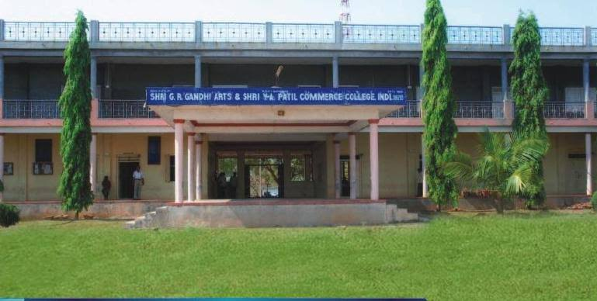
CRITERION VII - INSTITUTIONAL VALUES AND BEST PRACTICES
7.1.8 – Inclusion and Situatedness

7.1.8 - Describe the Institutional efforts/initiatives in providing an inclusive environment i.e., tolerance and harmony towards cultural, regional, linguistic, communal socioeconomic and other diversities.

7.1.8 - Describe the Institutional efforts/initiatives in providing an inclusive environment i.e., tolerance and harmony towards cultural, regional, linguistic, communal socioeconomic and other diversities
The institute plays an important role in providing an inclusive environment in order to maintain harmony among cultural, regional and linguistic, communal socio-economic and other diversities. Cultural integrity of environment that requires mutual respect, effective relationship and clear communication for a healthy campus culture which starts from uniformed dress code and national anthem recited by all. In this regard, to hold everyone’s respect and dignity the college assures equality, a well supportive environment by setting up the cells, extra-curricular activities which assure the inclusive environment to make a healthy atmospherein institution.
There are many Specific initiatives are taken by the institute to address locational advantages and disadvantages. Some of them are listed below.
1. Enabling the conduct sports event in our campus of other schools,college and society.(thereby creating awareness about our institution as well)
2. Enabling the conduct of several competitive exam by government and non government organizations
3. Offering Sports ground for companies for conducting their sports events.
4.Organised blood donation camp collaboration with BADIGER CLINIC ,INDI .
5. Enabling to held campus interview in our campus of several companies.

1. Enabling the conduct sports event in our campus of other schools,college and society.(thereby creating awareness about our institution as well)
PROVIDED OTHER COLLEGE STUDENTS & OUTSIDERS
SPORTS IN OUR CAMPUS
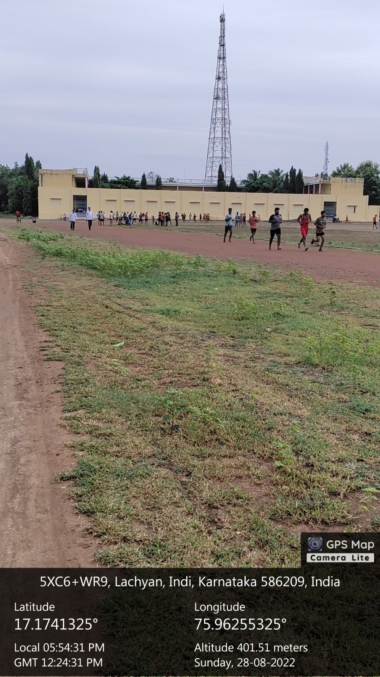
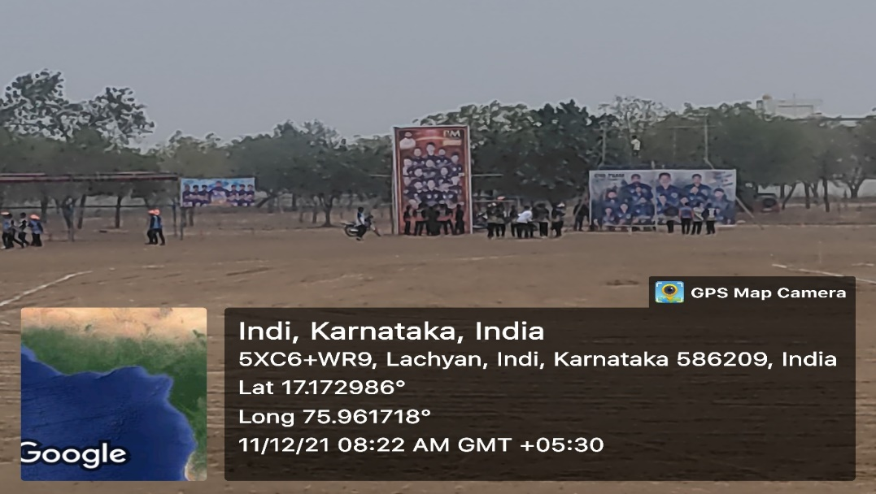
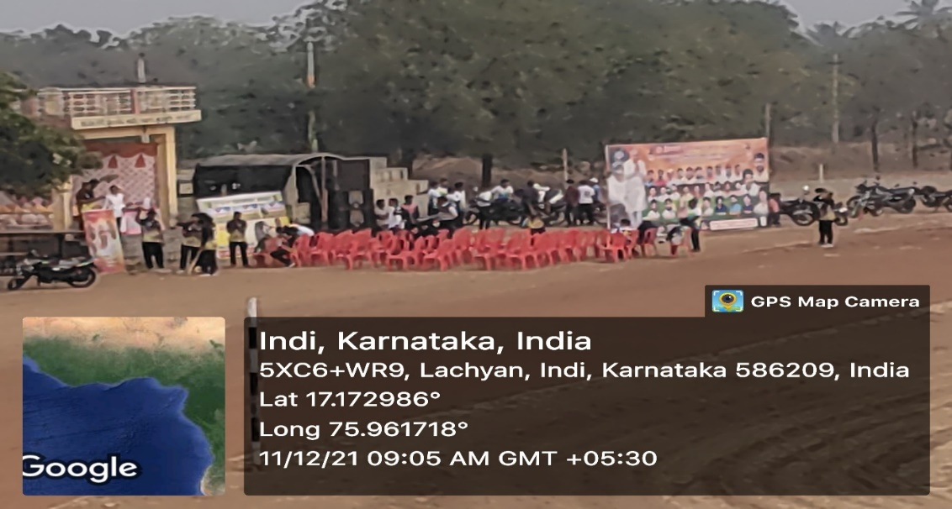
2. Enabling the conduct of several competitive exam by government and non government organizations
KPTCL JOUNIER ASSISTANT EXAM MEETING
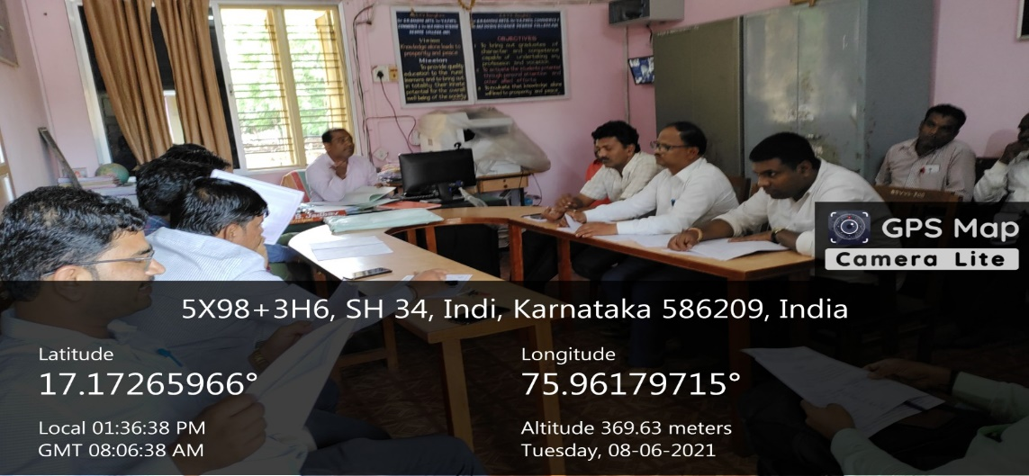
KPTCL JOUNIER ASSISTANT EXAM MEETING
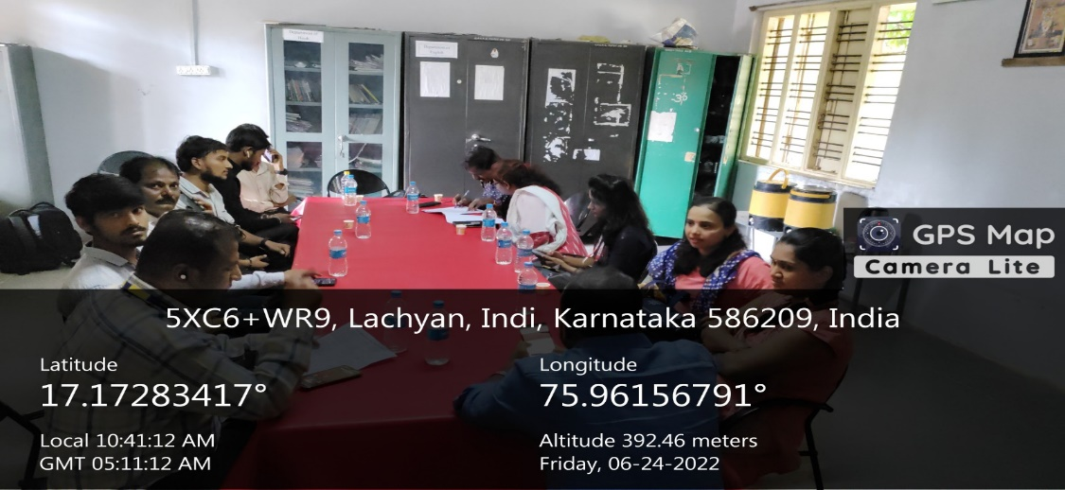
WORKSHOP ON COMPITATIVE EXAMS OF IAS,KAS,PSI,FDA& OTHER 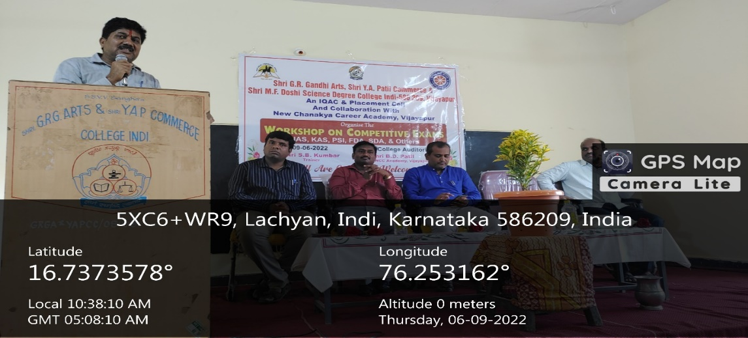
4.Organised blood donation camp collaboration with BADIGER CLINIC ,INDI .
BLOOD DONATION CAMP @ BADIGER CLINIC AGARKHED ROAD,INDI.
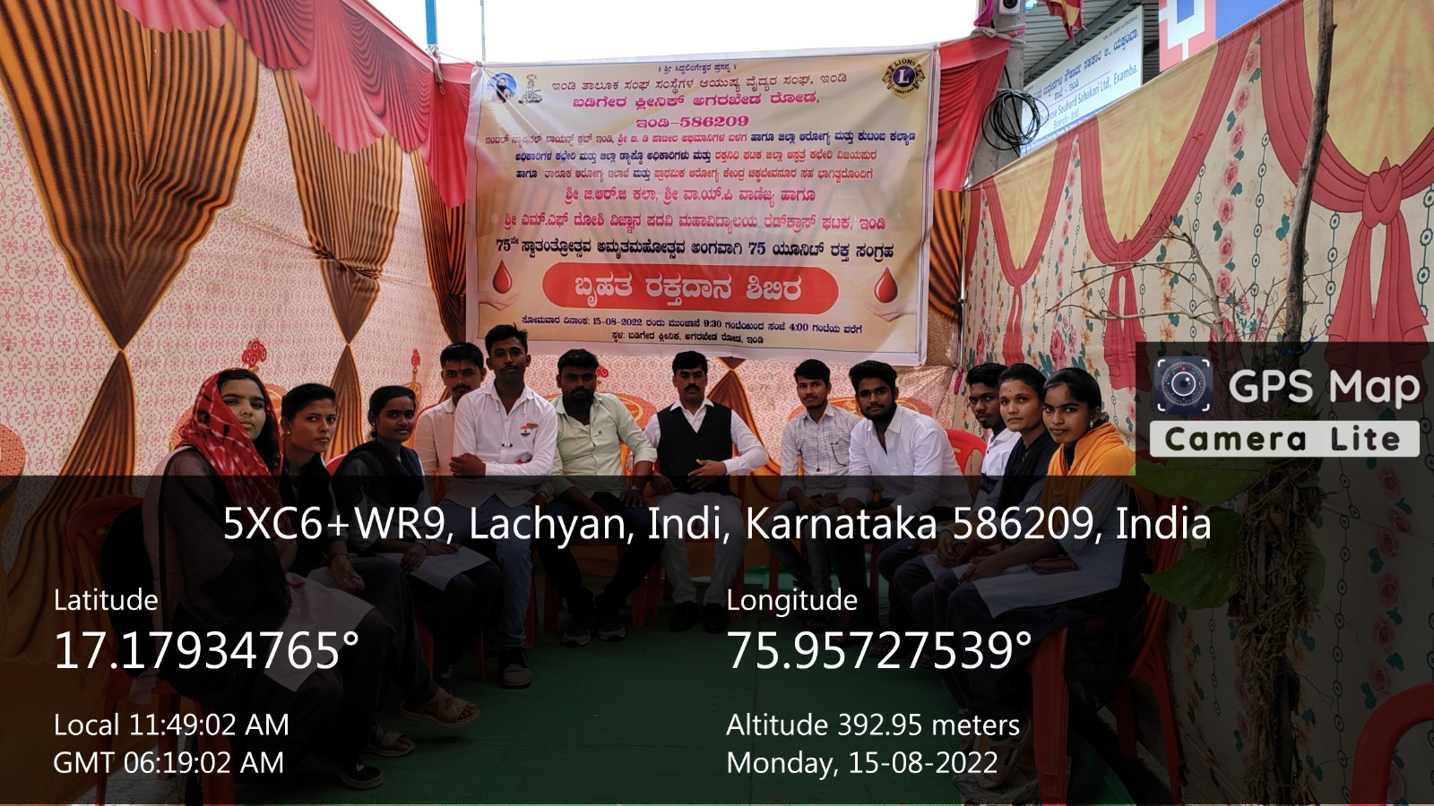
BLOOD DONATION CAMP @ BADIGER CLINIC AGARKHED ROAD,INDI.
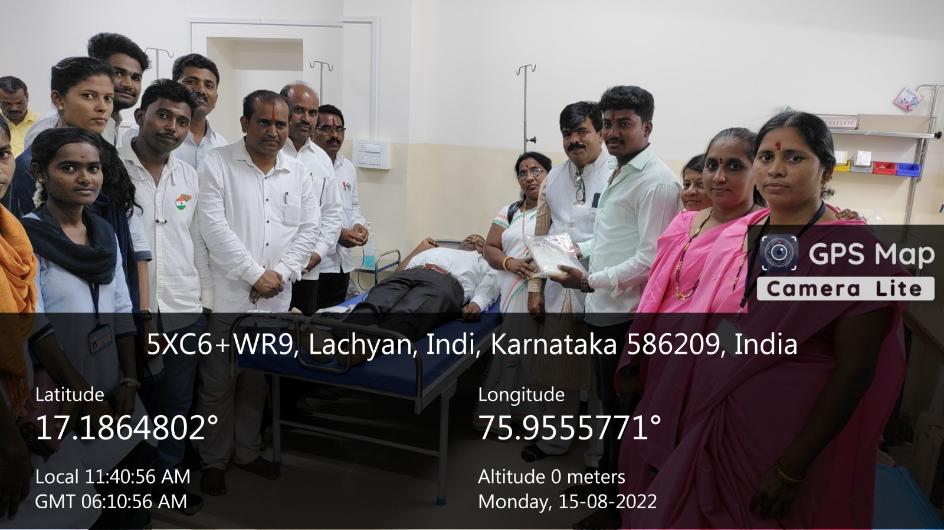
5. Enabling to held campus interview in our campus of several companies.
JOB FAIR IN OUR CAMPUS
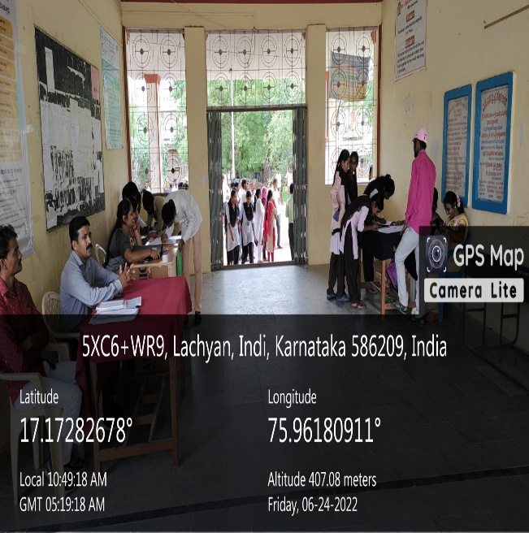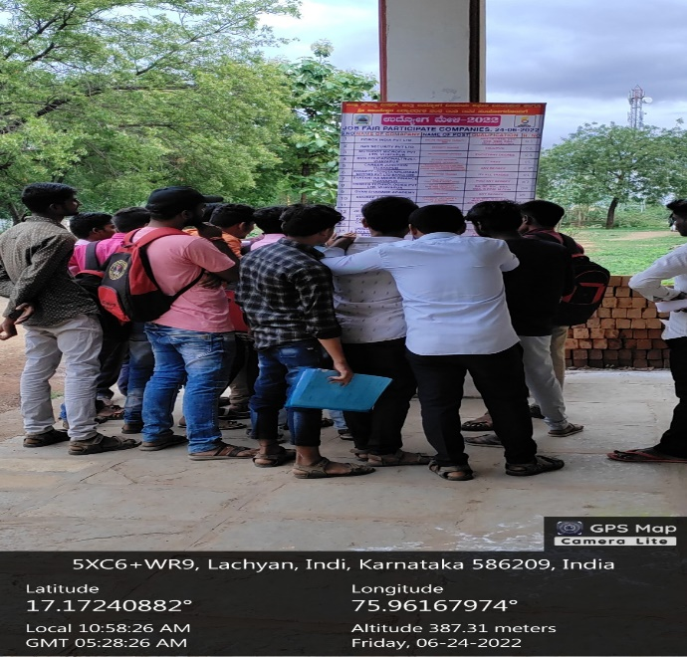
JOB FAIR IN OUR CAMPUS
